

Lab 2

Secure LAN Lab- Setup

ITSC 206: Advanced Networking for Offensive and Defensive Environments

Table of Contents

Lab Setup 4

Files/Download 4

Reading 4

Introduction 4

Initial Switch Setup 4

Windows 2k12R2 VM Network Setup 5

TFTP Settings on Win 2k12R2 5

Lab Setup

* Review architecture for each configuration and optimize.

OS Files/Download

* Win2k12R2 Image on Desktop
* TFTPD64 on Student Resources, rename from .txt to .exe

Reading

* None

Introduction

This document supports the setup of Lab2.

Initial Switch Setup

CiscoSwitch Initial Setup

Would you like to enter basic management setup? [yes/no]: yes ******

Configuring global parameters:

Enter host name [Switch]: student1sw1 *********change sw # if more switches are connected

The enable secret is a password used to protect access to

privileged EXEC and configuration modes. This password, after

entered, becomes encrypted in the configuration.

Enter enable secret: cisco *********

The enable password is used when you do not specify an

enable secret password, with some older software versions, and

some boot images.

Enter enable password: ciscotech *********

The virtual terminal password is used to protect

access to the router over a network interface.

Enter virtual terminal password: ciscotech

Configure SNMP Network Management? [no]: n *********

Would you like to enter the initial configuration dialog? [yes/no]: yes ******

Enter interface name used to connect to the

management network from the above interface summary: vlan1 *********

Configuring interface Vlan1:

Configure IP on this interface? [no]: yes *********

IP address for this interface: 10.0.1.254 *********

Subnet mask for this interface [255.0.0.0] : 255.255.255.0 *********

Class A network is 10.0.0.0, 24 subnet bits; mask is /24 *********

Would you like to enable as a cluster command switch? [yes/no]: no *********

Windows 2k12R2 VM Network Setup

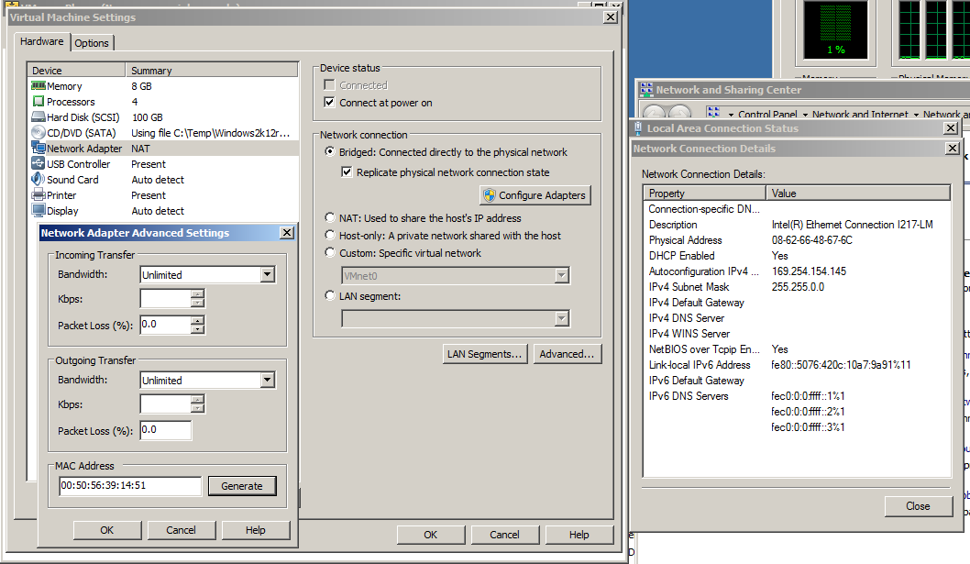

TFTP Settings on Win 2k12R2

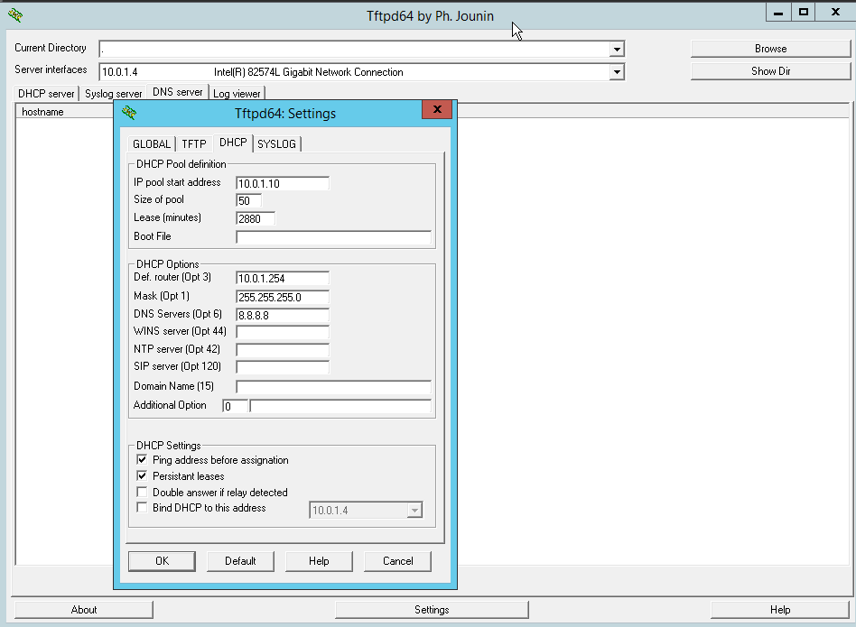

Blank page if necessary to make pages an even number

**DO NOT DELETE THE SECTION BREAK BELOW. DELETING IT MAY IMPACT THE FORMATTING IN THIS DOCUMENT.**